BUS 243 – Database Management Systems – Project Report

Mini Facebook Database

San Jose State University

Sameer Rajput – 013802841

Shubh Johri – 013750672

Divya Puraswani – 013755391

M.S. Data Analytics

Contents

BUS 243 – Database Management Systems – Project Report 3

Introduction 3

• Team Structure 3

• Objective / Business benefits and Goals 4

• Functional Requirements 4

• Technical & Infrastructural Requirements 4

Entity Relations 5

• Business Rules for ERD 5

• Database Schema & Entity Relationship Diagram (ERD) 6

Achieving Goals – Through Queries 7

Analyzing the Database – Through Graphs 10

User Interface 12

Conclusion 14

• What we learned from this Project 14

• Future Work 15

BUS 243 – Database Management Systems – Project Report

# Introduction

In the modern world, a social networking website is not just a mere source of interaction with people but instead, has become a major source for brand awareness, community engagement, content distribution, sales and lead generation and customer support. Out of these, community engagement holds a bigger part and is the main reason why social networking websites came into being. With the fast-growing business of social networking sites, our purpose was to explore how these websites maintain their databases of such big data of their users. Hence, we decided to try and build a database using fictitious data of a shorter version of a social networking website, and we called it Mini-Facebook. Mini Facebook is a social networking website that lets its users connect with one another. It provides its users the capability to be friends with other users and to post statuses on their own walls and post-messages on their friends’ wall. Mini Facebook has some basic key features extracted from any social networking websites we see these days like posting statuses, wall messages, commenting on those posts and uploading pictures.

## Team Structure

|  |
| --- |
| Project Faculty Guide: Dr. Subhankar Dhar |

|  |
| --- |
| Students: Divya Puraswani 013755391  Sameer Rajput 013802841  Shubh Johri 013750672 |

## Objective / Business benefits and Goals

* With Mini Facebook Database, we want that it becomes convenient for Mini Facebook to be able to give out friend recommendations to the users.
* To be able to view the mutual friends and friends of friend.
* To let users view, upload and comment on posts and photos.
* To let Mini Facebook, notify the users of their friend anniversaries.

## Functional Requirements

A functional requirement defines a function of a system and its components. A function is described as a set of inputs, the behavior, and outputs. Following are the functional requirements of Mini Facebook-

* Login Form

Input: Login Email and Password

Output: Valid User Access

* User Details

Input: Enter name, date of birth, address, city, Email, Password

Output: Details Stored

* Post Details

Input: Upload status, photo, wall message etc.

Output: Details Stored

## Technical & Infrastructural Requirements

* Operating System Windows 10, Mac OS
* Database MySQL
* Data Management phpMyAdmin
* Web Server XAMPP
* ERD MySQL Workbench
* Graphical Analysis Tableau
* Data Fictitious – Online Data Generator
* Front-end Design php

# Entity Relations

## Business Rules for ERD

* We allow many users to join our website. Each user is identified by the key u_id. They can join Mini Facebook, by entering their basic details like Name, Date of Birth, Email ID, Password etc.
* Existing users can login by their Email ID and Password.
* A user can have zero to many friends and a friend belongs to a single user. Friends are users too, hence, there is a two-way relationship between them.
* A user can have zero to many posts and one post can be posted only by a single user. So, a post is unique to a single user.
* A post can either be a status or a wall message, and both the status and wall message can be in the form of either text or a photo. We define status as a post on the user’s own wall and wall message as a post on the friend’s wall.
* A post contains zero to many photos and a photo is contained in a unique post.
* Similarly, a post can have multiple comments and a comment is unique to a post. A comment in our model can be on statuses, wall messages and photos.

## Database Schema & Entity Relationship Diagram (ERD)

Following table shows the entities and their relationships:

|  |  |  |  |
| --- | --- | --- | --- |
| ENTITY | RELATIONSHIP | CONNECTIVITY | ENTITY |
| User | Has | 0:M | Friends |
| User | Uploads | 0:M | Posts |
| Post | Has | 0:1 | Status |
| Post | Has | 0:1 | Wall Message |
| Post | Has | 0:M | Photos |
| Post | Has | 0:M | Comments |

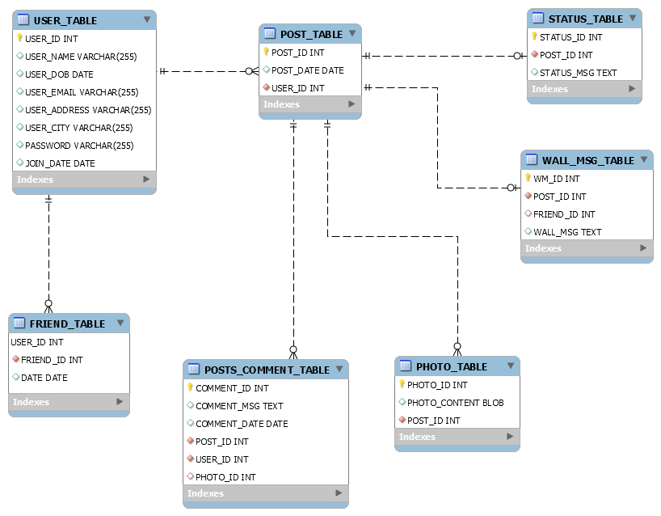

# Achieving Goals – Through Queries

1. To display all the statuses of an individual user; ‘Magee Harper’, in this case.

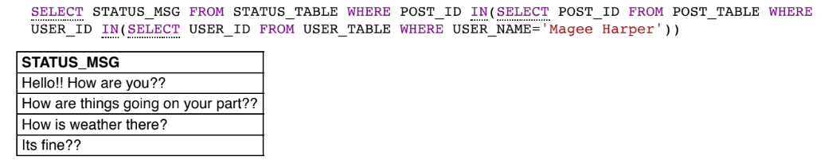

1. Mini Facebook can send E-cards and birthday presents to its users. The following query shows the birth date of all users between two dates.  
   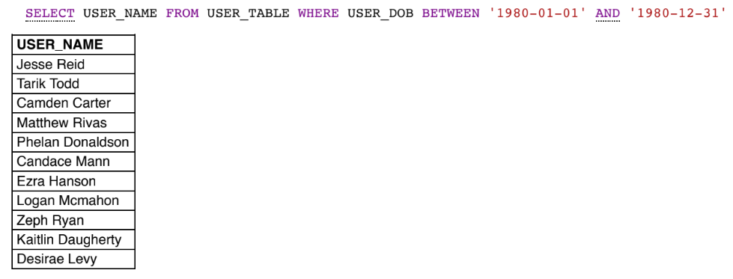
2. Mini Facebook uses a recommendation system to recommend possible friends of a user. Hence, we the run the following query to get the Friend and Friend-of-Friend. In this case, user 2 has a friend user 90 and user 90 has a friend user 4. So, user 4 can be recommended to user 2 for friendship.

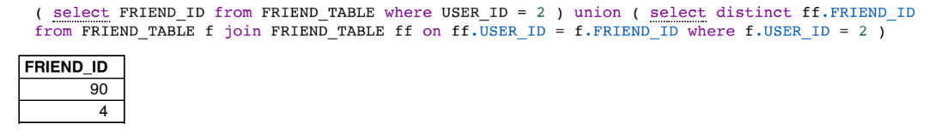

1. To display mutual friends – It helps Mini Facebook to send friendship anniversary videos to its users. The below query shows that user 35 is a mutual friend of users 58 and 54.

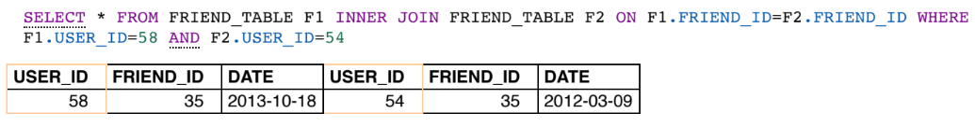

1. To view comments of users between two different dates.

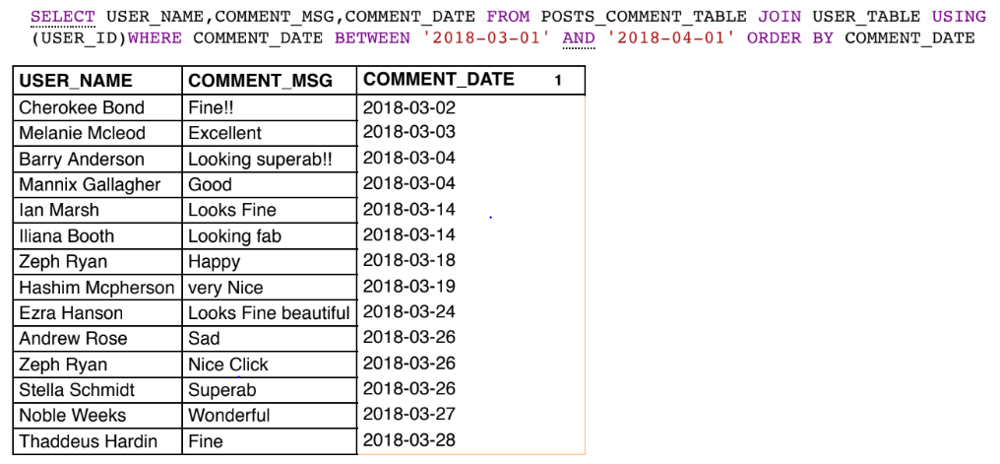

1. We can also view which friend belongs to a particular city. For example, we can check which friend comes from the city ‘Pozo Almonte’.

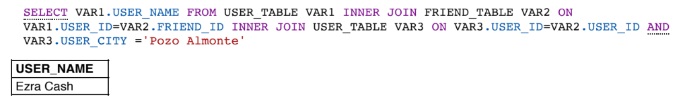

1. Number of Posts grouped by User ID-

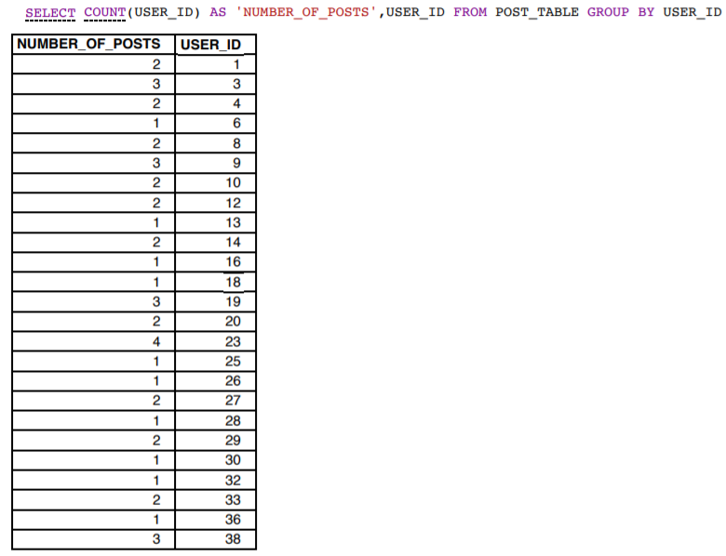

1. Display the photo content of any user –

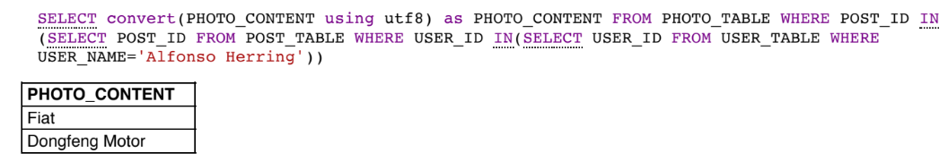

# Analyzing the Database – Through Graphs

Using Tableau, we generated some graphs to describe our database.

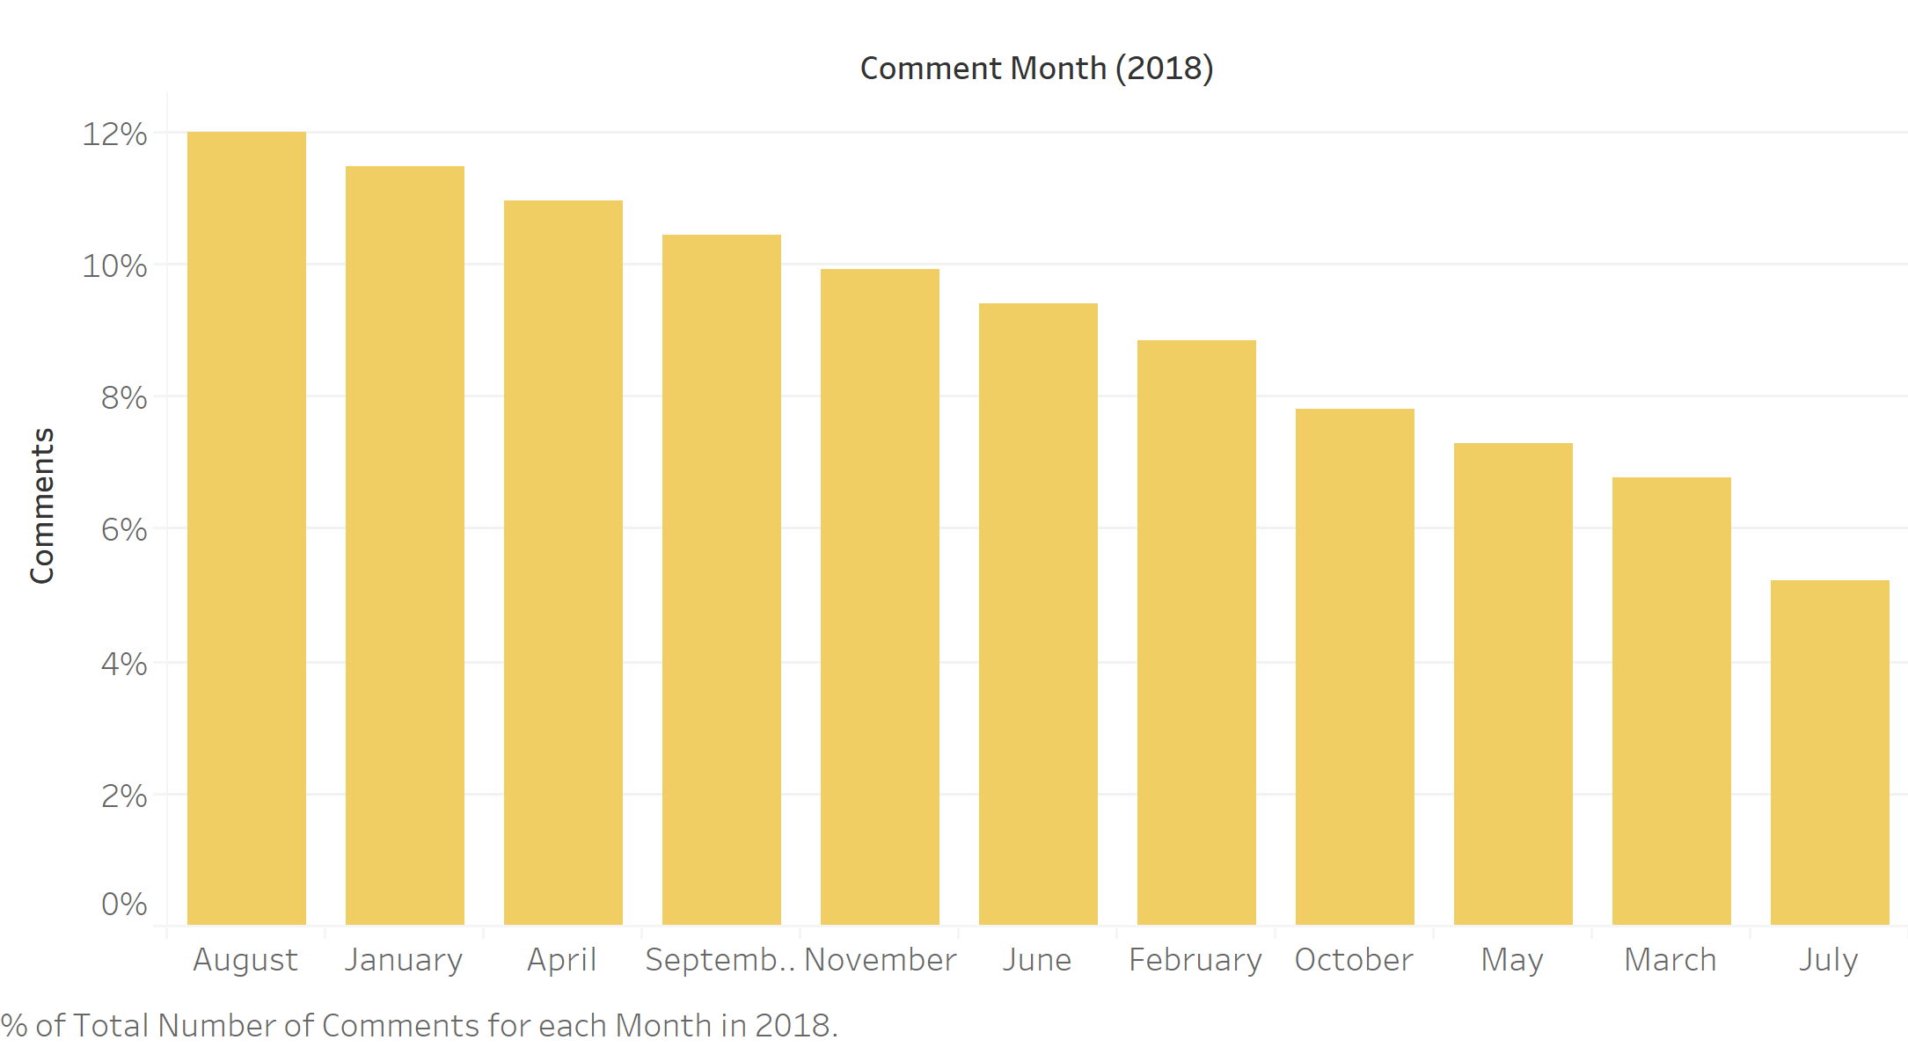

Figure 1: Percentage of comments in 2018 month-wise.

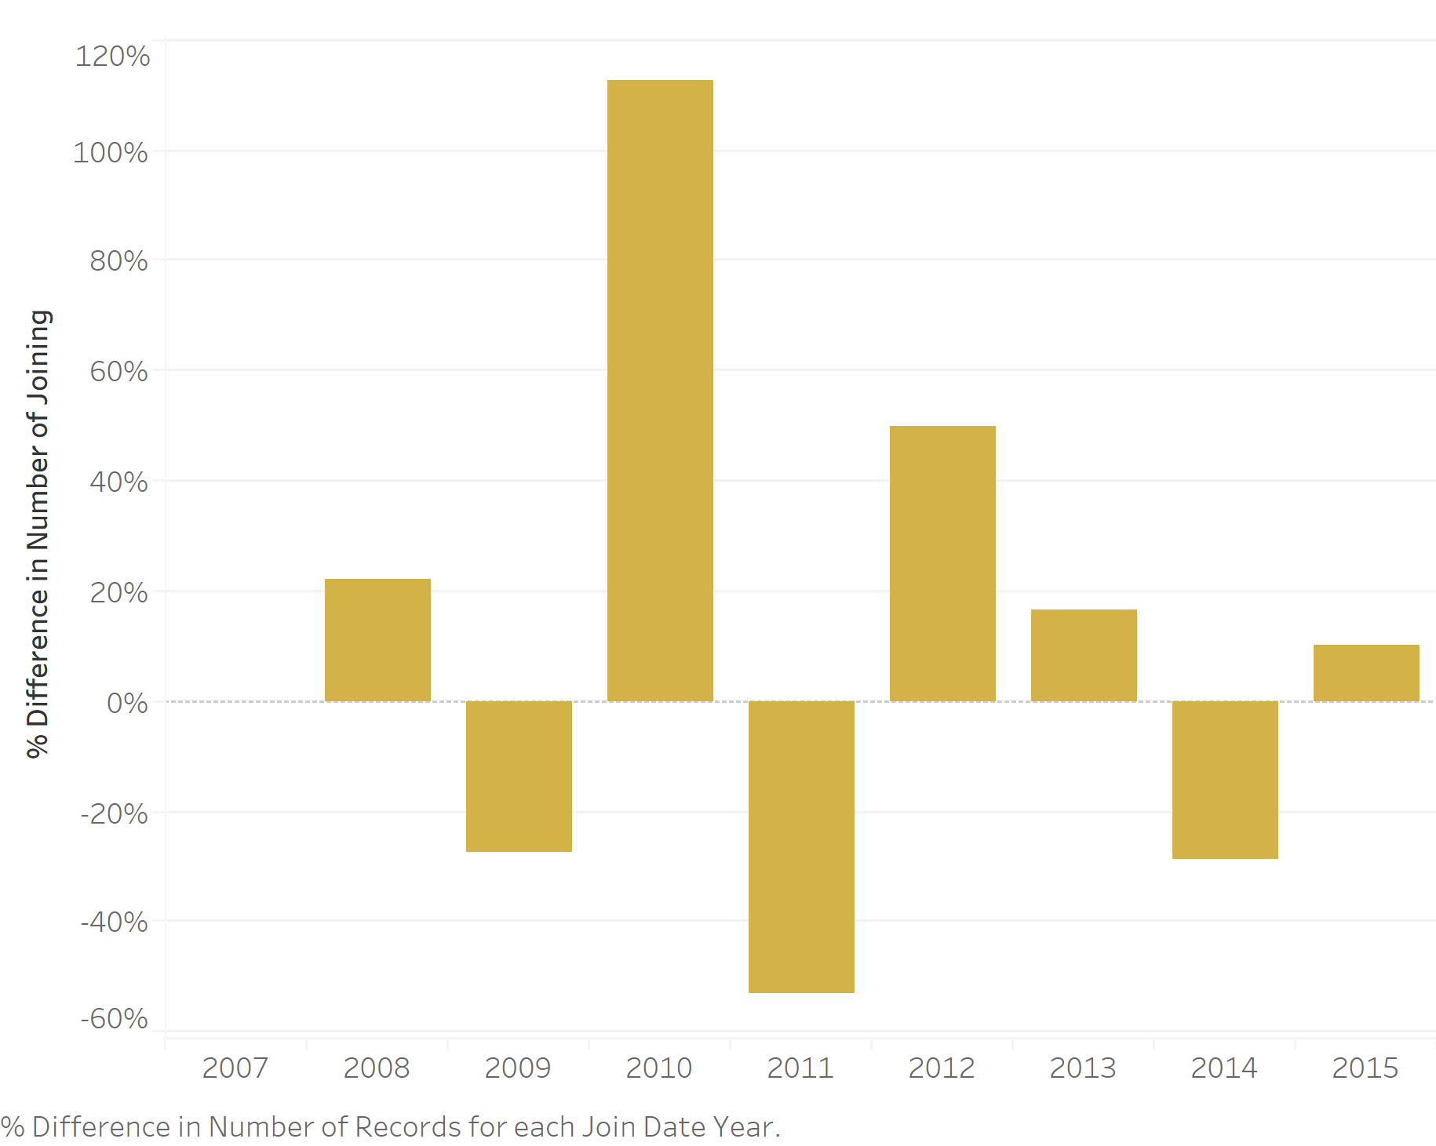

Figure 2: Percentage Difference in No. of Users who Joined yearly.

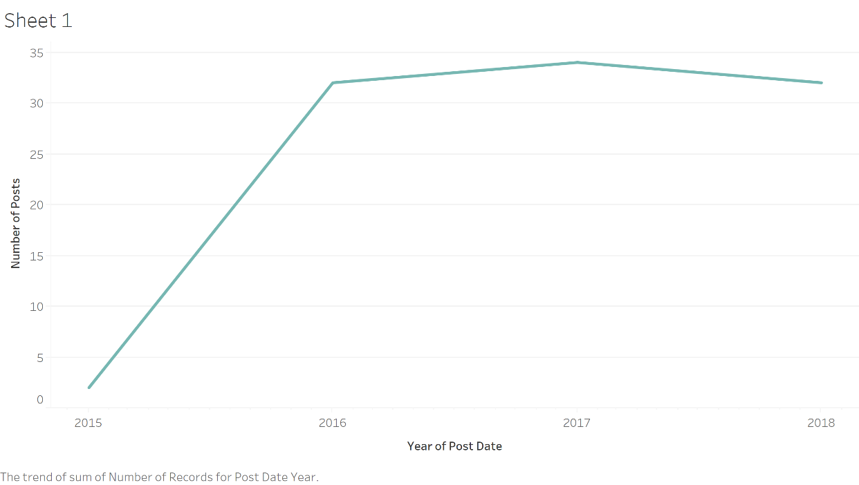

Figure 3: Number of posts yearly

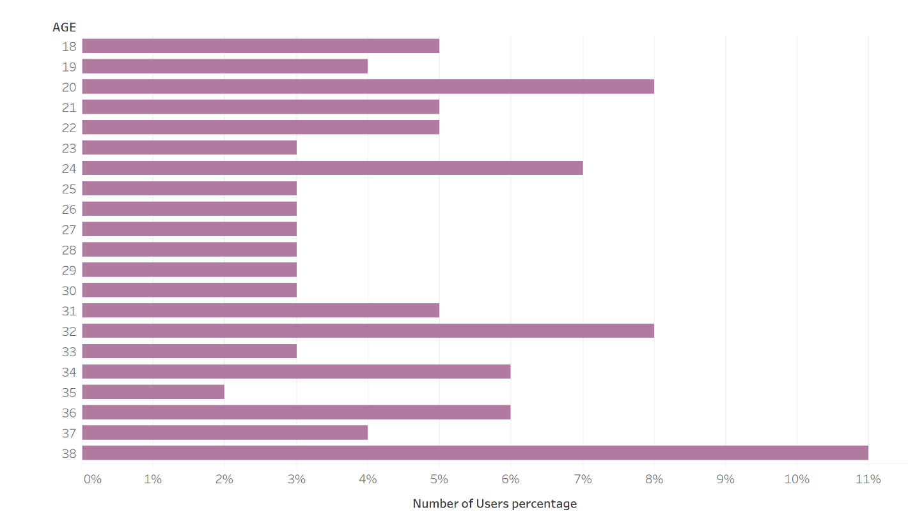

Figure 4: Age demographic of Mini Facebook Users

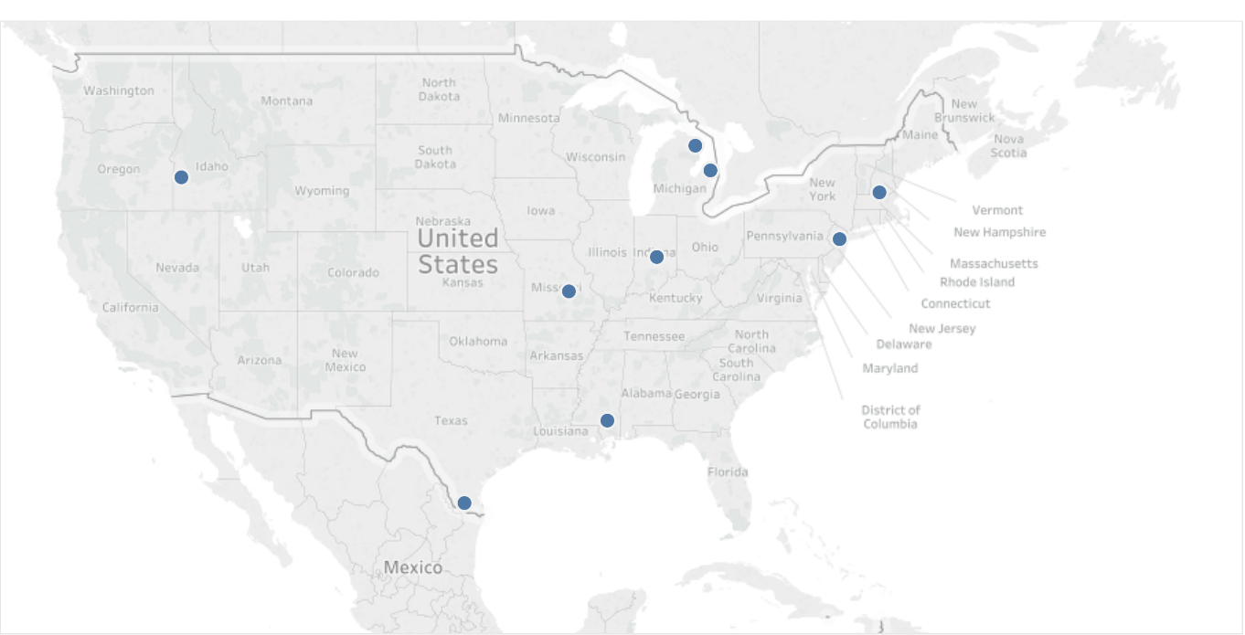

Figure 5: Where our majority of Users are concentrated in US

# User Interface

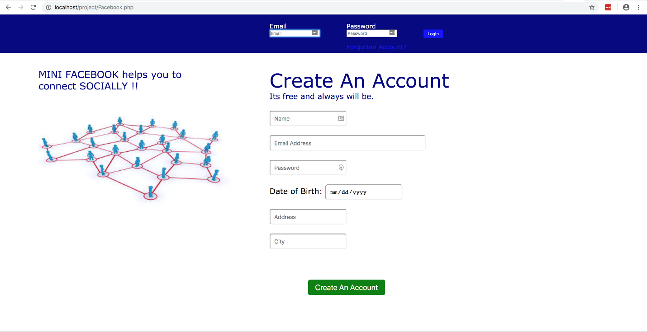

Figure 6: Front Page

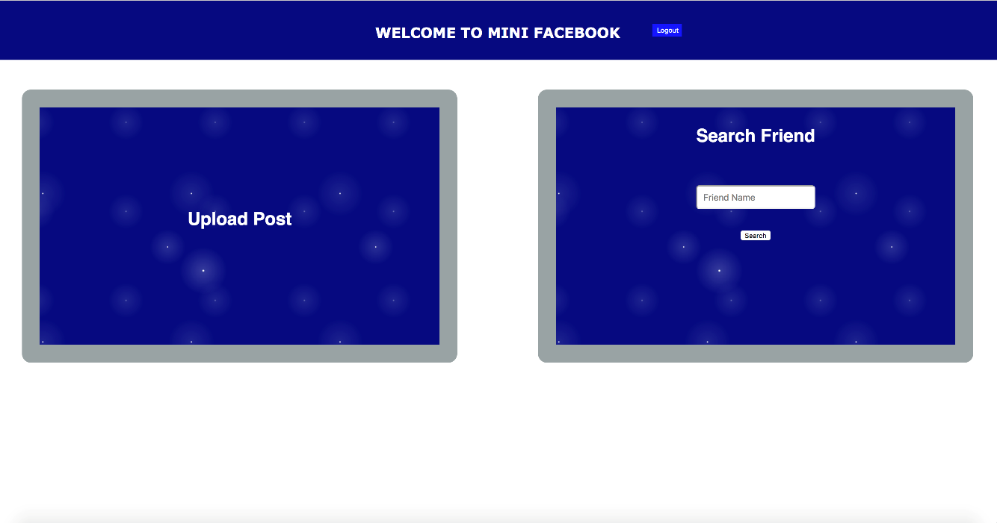

Figure 7: After log-in

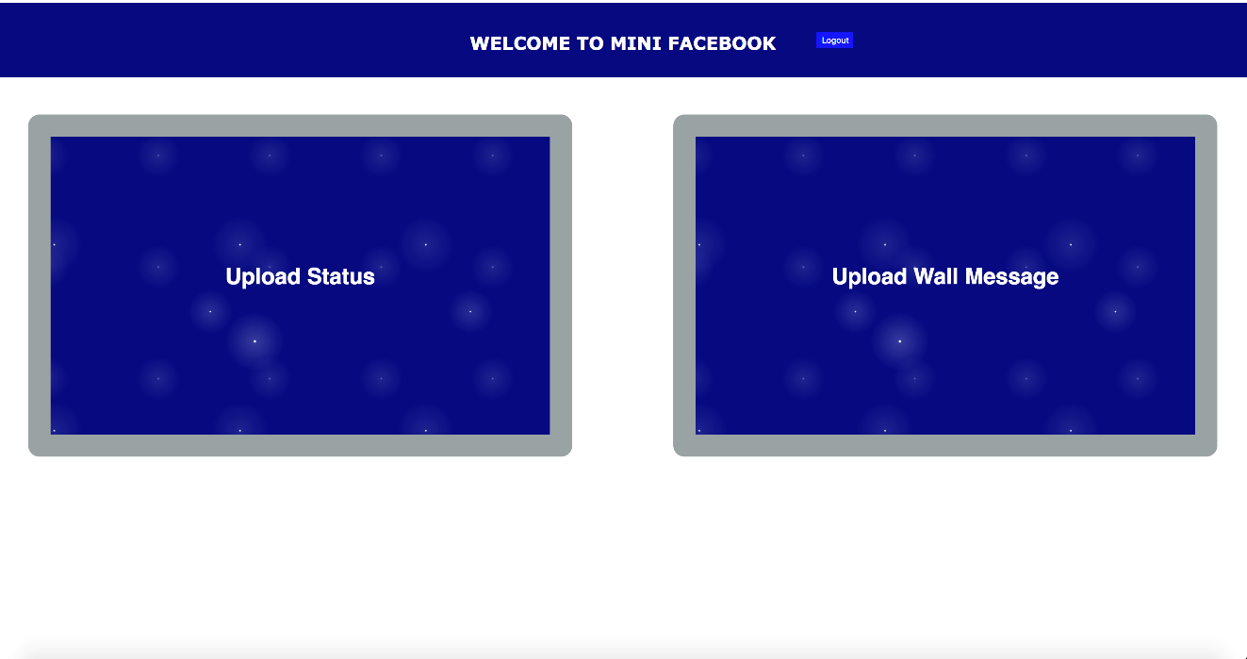

Figure 8: Upload Status/ Wall Message

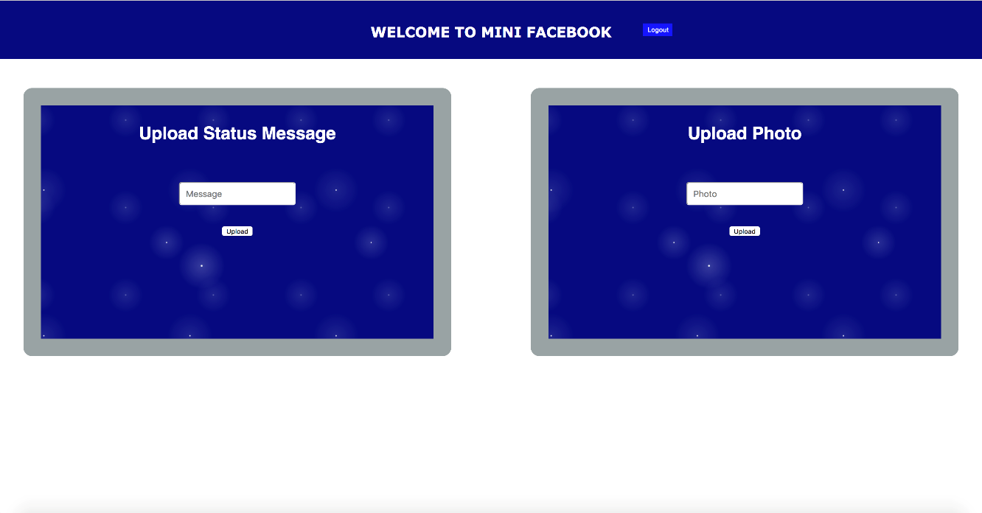

Figure 9: Upload Status Page

# Conclusion

## What we learned from this Project

While completing this project, we were able to apply database management skills and knowledge gained in class. Working with SQL queries, we learned how to analyze the database, its structure and the relationships within the database. Also, we understood the concept of recursive queries, joins, aggregate functions, etc.

How to develop user interface using PHP and connecting the database with the user interface was another challenge we addressed which strengthened our leaning.

Querying our database, Mini Facebook could find results like mutual friends and recommend users about their potential friends. With Tableau, we were able to visualize our database and gain business insights to know the activities of our users.

## Future Work

1. In this project, we have used PHP and HTML languages, however, we propose other multiple languages like Cascading Style Sheets, Java Script and AJAX, which can prove to be more functional in User Interface design.
2. Also, databases like MongoDB or Neo4j can better handle unstructured data of Mini Facebook.
3. Include security measures to secure our user data by distributing the data among various servers at different locations.